**Chapter 75 - KEN’S PARENTS & SIBLINGS**

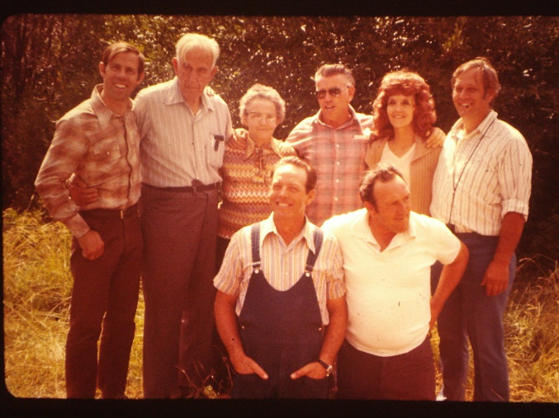**Ken’s mom remarried after Charles (Ken’s father) died in March of 67. She married Leo Jensen in June of 1970.** He is a wonderful man and we love him. He was a temple worker and now she is. They serve in the Idaho Falls Temple.

This is a family picture taken at a family reunion with Marge’s children – Rich (Dad Browning’s youngest son by his first wife), Margaret (Marge’s daughter by her first husband, Less), Roy (Ken’s older brother – he, Ken & Irven are children of Marge and Charles Browning), Irven is standing at the left of Leo Jensen. Ken is on the front with his older brother, Bob (Floyd Robert), but he was called Bob. Bob was also a son born to Marge and her first husband, Less). Leo and Marge live at the time at 90 Boise Ave. in Idaho Falls. They are happy.

Leo was about 15 years older than Ken’s mom. She, Marge, waned to be closer to her family and Marge didn’t like living in the home his first wife and he had built together, so they bought a home in Layton. They had several happy years together and then he passed away.

I have written about Ken’s mom in other chapters.

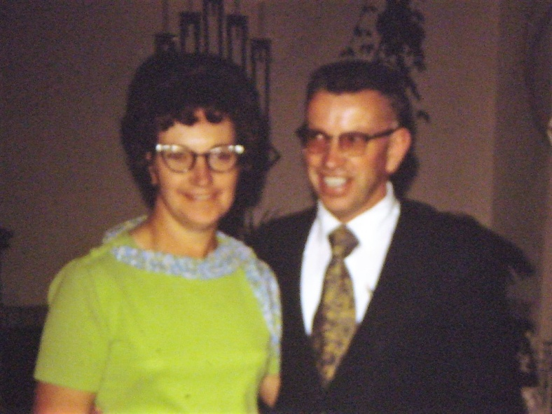 Rich & Lois live in Pocatello, Idaho. They have raised a wonderful family who are all active in the church and are raising good families. Rich & Lois are such good people and good examples. They have always supported their siblings and families in all we do. If there is a reunion, wedding, funeral, birthday party for Ken’s mom, etc., they are there, and they bring part of their family with them. We love and admire them, and we love being with them. We are always welcome at their home and they love us to stay overnight, and they feed us and we always play Mormon Bridge at night and have ice cream. Rich loves that game and loves ice cream. I have written in another chapter about the wonderful times we have had with them at their condo at Island Park. They had snowmobiles and the four of us would trailer the snowmobiles into West Yellowstone and then I would get behind Ken on one, and Lois would get behind Rich on the other and we would go all through Yellowstone Park. It was so beautiful with lots of snow. We would see lots of Buffalos and other animals. There was “warming huts” when you could go in and they had fires going in the stoves and you could buy hot chocolate, etc. We also went up other hills and mountains as the forest service would groom many trails. We always loved being with Rich and Lois. At the condo we would come in from snowmobiling, eat and then go to the club house where there was a warm indoor pool, ping pong tables, etc. We would go back to the condo and play “Mormon Bridge and eat ice cream. Whenever we stayed with Rich at Lois at their home or condo, we would always end the night by reading the scriptures together and having a prayer together. They are such righteous, faithful, wonderful people. We sure love them, and their special family. This is a picture of Lois and their children after Rich had passed away. They are: (from left to right, back row & then front) Elise, Devin, Phillip, Dale, Carla, Lois and Joyce

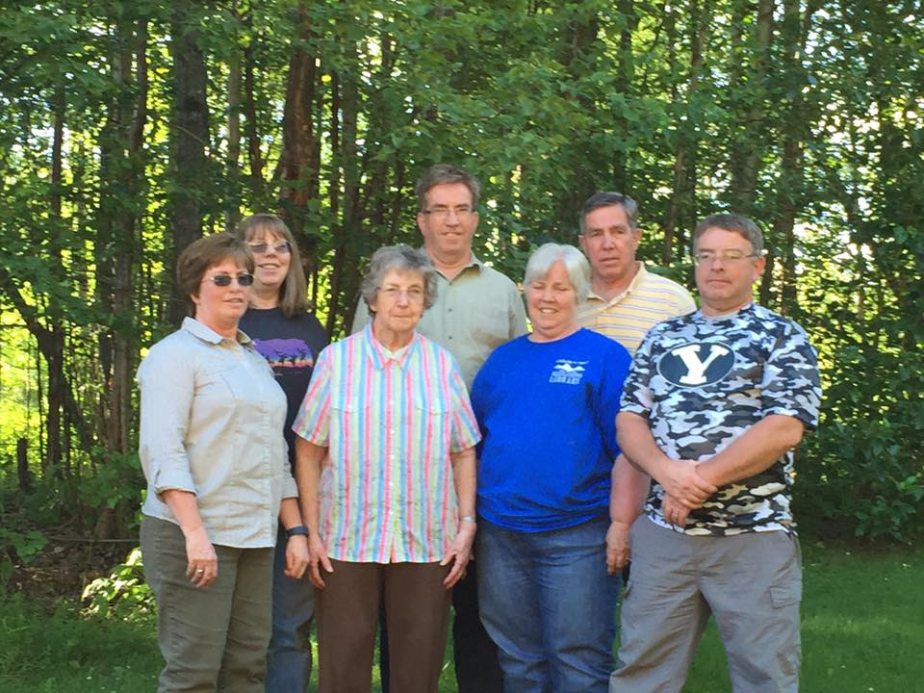

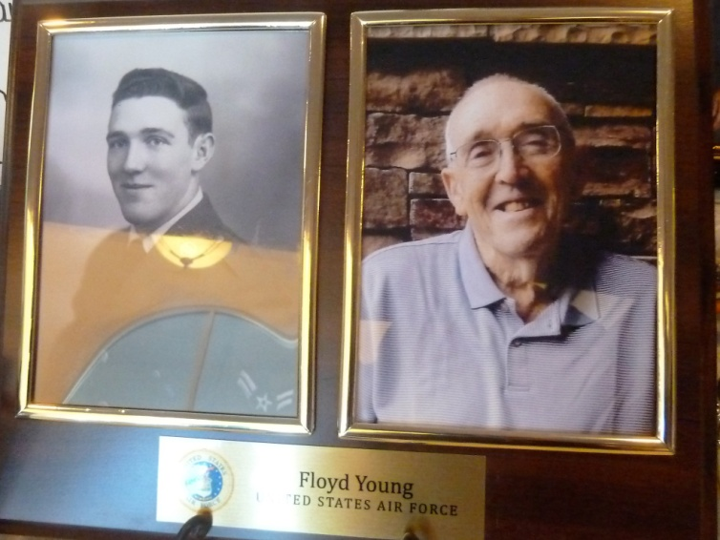

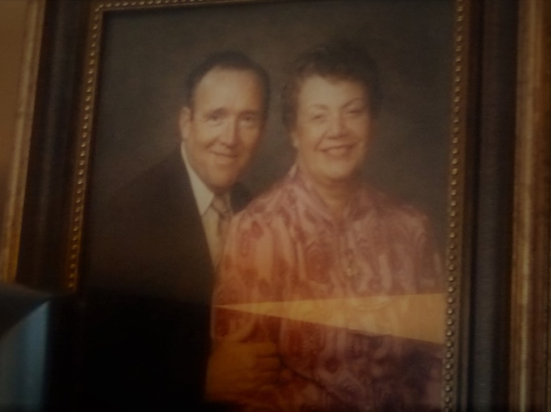**Bob, Carroll and family** have retired from the Air Force and are now living in Sunset, Utah. They had 5 children, but the one daughter died soon after child birth, so they raised four children – **Kathy, Grant, Robert, & Sherry.** Kathy & Sherry left the church. Kathy lives in Texas, Robert, Patty and children live in Honeyville Utah, Grant & Stacy live in Layton Utah, and Sherry, Eric and Cole live in Syracuse Utah. When we came back from our mission to the Philippines, we again lived in Bob & Carrol’s basement apartment, that Ken had built for their mother. We had lived there for a few months, taking care of their mother as she had Alzheimer’s disease. As we had sold our home in Layton to Scott & Mishelle and had planned to build on our lot in Star Valley, Wyoming. (I have written all about this in other chapters.) Anyway, it worked out well living there with Bob & Carroll. We shared all the expenses – utilities, property taxes and home insurance, repairs on the home, replacing the furnace, etc., etc. Bob mainly cooked even though Carroll was a good cook, because Bob would complain at times about her cooking and she didn’t like to cook, so told him, he would do it. They would invite us up for meals sometimes, especially on Sundays when we weren’t having our family over for dinner or going to their homes. Carroll loved to play Canasta and that was about the only game she wanted to play. We all enjoyed playing it. Bob would pop, pop corn and we had enjoyable evenings.

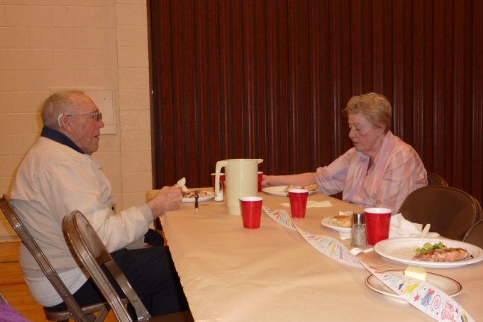Carroll got dementia and was imagining all kinds of things that were not true, and was so upset because no one would believe her. She thought the neighbors were stealing their electricity, she knew they were up in their attic stealing things, etc., etc. She called the Bishop to come check it out, she called the police several times until they quit coming. That was a hard time for all of us. Carroll was always good to me. She had health problems and her legs and feet would swell so big. I felt sorry for her. Sometimes I would go up and clean her bathroom and kitchen and she always appreciated it. She didn’t like Ken’s mother cleaning her house for her, but now that her health was bad, she appreciated me doing it.

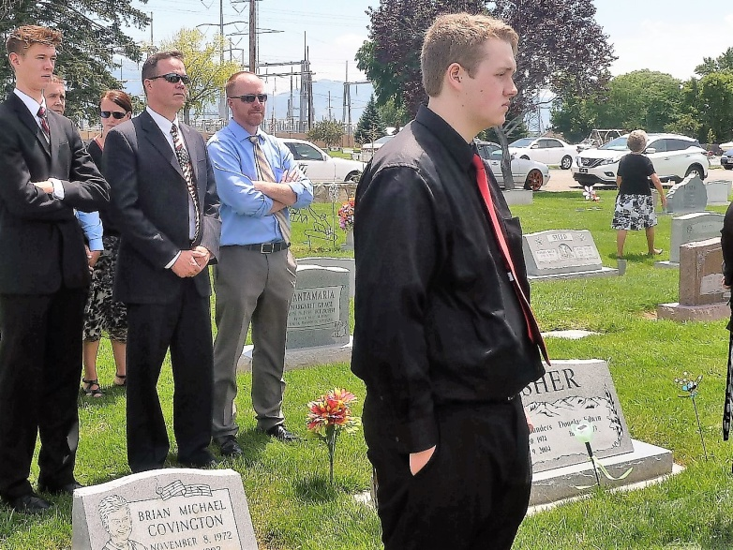Carroll had a severe stroke and passed away in the hospital a week later. Sherrie had a child, Cole, out of wedlock. Carroll would take care of him while Sherry worked. As he went to school, Carroll would go down at 6 am and stay with Cole and get him off to school as Sherry had to go to work early. What a wonderful grandmother Carroll was to Cole. When Carroll passed away, Cole was heartbroken as he loved his grandma so much. Sherrie married Eric, they bought a home in Syracuse. They both drank heavily. Sherry ended up dying from Alcohol consumption a year after her mother passed away. **Cole** has turned out to be a great young man. He got straight A’s in school and wanted to go to college, so he is living with his grandparents (His real dad’s parents) and going to Weber University. Bob & Carroll never knew that Sherrie drank. She was talented with food services, like her dad, and had good jobs for awhile, but kept getting fired because of her drinking. Bob was devastated when Sherrie was in the hospital and he was upset with the doctors that they couldn’t heal Sherrie. They told Sherrie that either she told her father, or they would. This was hard on Bob. After Carroll passed away, Bob wanted to remarry so he asked me to look for him ladies to date on the “Mormon Singles Date Site” on the computer. I found a couple and he dated them once each. He realized that they all were older, like him, so had health problems and they all had baggage, so after a time, he gave it up. Bob was a great baker, as he had done that in the Air Force, so he made delicious pies and brownies. He would rap on the door, or up by the stairs and when I came to the door, he would say “Mae, I made a coconut cream pie. I know Ken can’t eat it because of the sugar, but you can, so come and have a piece with me.” I loved them. At Thanksgiving, he would make all kinds of pies – apple, pumpkin, cherry, banana cream, coconut cream, lemon, etc. Carroll made a soda cracker pie that was delicious too.

The main thing that was annoying about them was that when they wanted Ken to do something or fix something for them, they wanted it done right now. Ken had other things that he needed to do, but he would finally give up and do it for them. Bob kept doing that after Carroll passed away. If we didn’t get to the door right away, he had a hammer and would pound it and make a real racket. We told him to have patience, that it took a minute or two for us to get to the door if we were back in the bedroom or bathroom.

Bob’s health kept failing, so his kids felt he should be in an assisted living center. Stacey (Grant’s wife) found a nice one in Layton and they moved him there. Grant & Stacey did a lot for Bob and made sure that he had everything that he needed. Robert & Patti would come down on Friday afternoons and take him out to eat. Ken and I had to move also, since Bob & Carroll had put their home on a reverse mortgage. We bought a mobile home in the Monte Vista Mobile Home Park – a very nice senior living park in Roy and we are happy here. We have a small lot, but it is beautiful with trees, bushes and flower gardens. We also have a garden box in back. It is nice not to have such a large garden and yard to take care of as Bob & Carroll had an acre lot and it was mainly Ken & I to take care of it. Bob, would mow the lawns with his riding lawn mower before his health got worse. We visited Bob in the Assisted Living Center quite frequently and so did Irven & Sandy. **Of course his children did too**, and Cheryl, Margaret’s daughter. We would sometimes go and pick him up, bring him to our home for Sunday dinner and then take him back. When we visited him in the center, he would want us to watch a movie with him. Bob loved the TV, he loved watching all kinds of sports, western movies and about anything. It was hard to visit with him because his hearing was so bad, he couldn’t understand us, so we had to write on a whiteboard. So, TV movies and DVDs worked for all of us. He always had cookies in his cupboard that he would offer to me and he would get popcorn, from the kitchen to give to Ken. He was cute that way. I really liked Bob as he was usually happy and positive, even when he didn’t feel good.

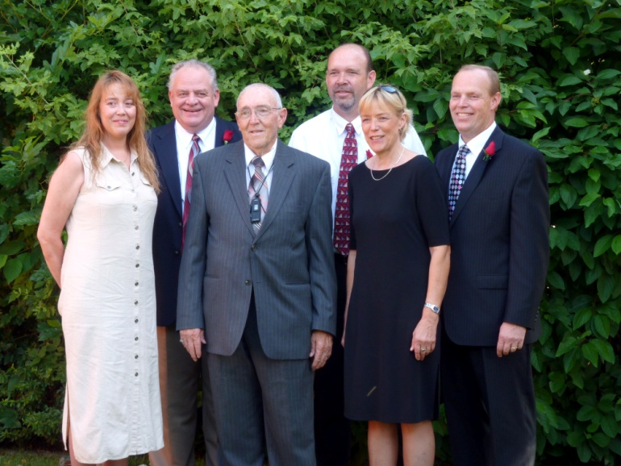

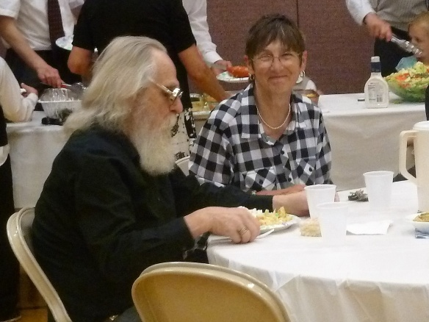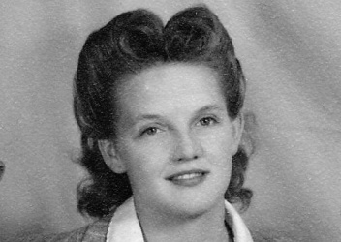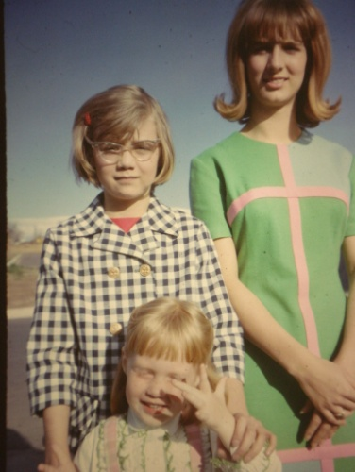**Margaret** and family are living in Salt Lake. Margaret has had a hard life due to her making bad choices by drinking, marrying guys she meets in the bars. She flirts with the other guys at the bars and then her husband (She has married 8 times) takes her home and beats her. After she divorced her last husband, she stayed with us for a couple of months and I saw a better side to Margaret and was thankful for that time with her. She died at age 55 from alcohol and other complications. At the autopsy, they reported that her insides looked like scrambled eggs from the beatings she had taken – so sad. Her second daughter, Linda, was a sweet girl, but died in her 20’s with a hole in her heart that should have taken her at birth. She was able to marry and they adopted a child. Margaret’s oldest daughter, **Cheryl is a gem.** She is such a wonderful person. Her mom forced her into marrying the brother of her current husband. He drank, smoked and wasn’t a great guy, but Cheryl stuck with him as she didn’t want the life her mom had. Cheryl got active in the church later on, and Bob eventually joined the church also. He has really poor health now. They lost a daughter to phenomena, and Cheryl practically raised them as the daughter’s husband stayed with them, but couldn’t handle all this responsibility, so Cheryl took over. The picture above shows Cheryl (the oldest), then Linda and our daughter, Sandi, was with them.

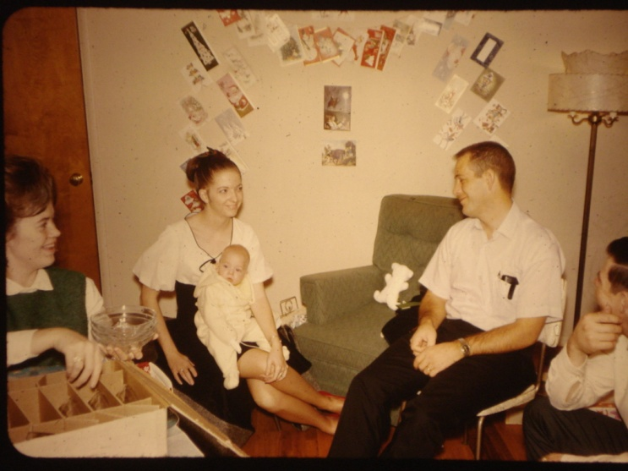

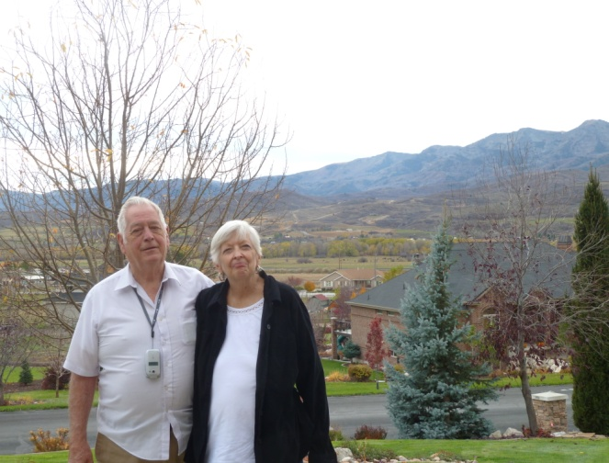**Roy, Linda and two children**, Steven and Barbara, are moving to Fresno, California the first part of September. They don’t like the snow and Roy was able to get a transfer to Fresno with IRS. Linda was able to have children, so they adopted Steve & Barbie. Linda got pregnant with Julianna when she was 40 years old. Steve got into drugs when he was a teenager, but got off them, went on a mission to Hawaii, came home and married a beautiful girl in the temple. She died about a year later from a disease she had. Steve had a terrible time and finally married another beautiful girl, and had two children. He treated Heather badly and she finally divorced him. He went back to drugs, but moved to Texas where she was living with her parents, so he could be near his children. They found him dead in a bar – so sad. Barbara married a great guy in the temple and they had four children. They are doing good.

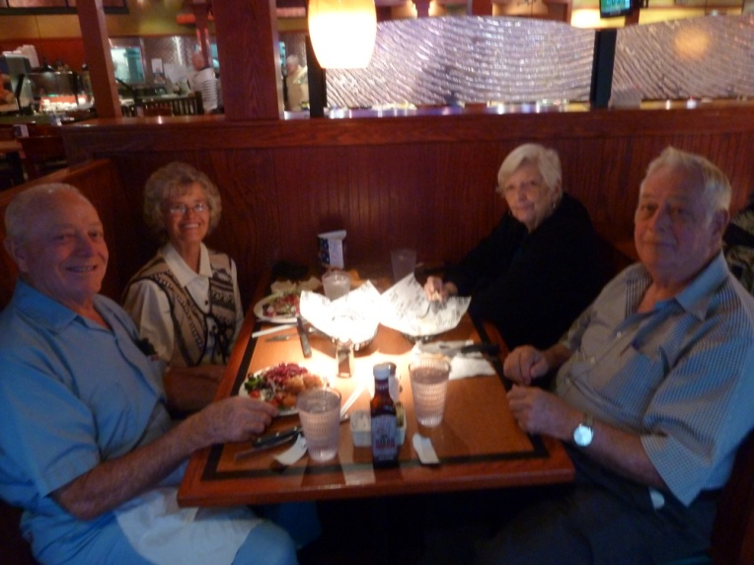When Ken and I were on our service mission to the South Valley Farms in Wasco California, from March 2010 to March 2011, it was only an hour’s drive to Fresno, so we would go over to visit Roy & Linda several times on weekends. They loved having us come and we were glad we could. Sometimes we would go to the Fresno Temple with them, stay overnight and go to church with them, and then come home. We went on several trips with them. One trip to Yosemite National Park, one to San Francisco, and one to Hollywood and other places in Las Angeles. We went on a tour bus, which was great! They came to our home sometimes on the weekends and stayed overnight with us. They invited Ken and I to come for Christmas Eve and stay over for Christmas day. We did and had a wonderful time. On Christmas Eve, they drove us to a special area where all the homes were decorated and lit up so great. We walked up the one side of the street and then down the other side, it really made you have the Christmas spirit. The weather wasn’t cold like it is in Utah, but we did wear jackets. On Christmas morning, Ken and I woke, but Roy & Linda wee still sleeping, so we got on our swimming suits, picked some oranges from their tree, got in their hot tub, ate the oranges and enjoyed being in their hot tub. They finally woke and came looking for us. They laughed when they saw us. We all opened our gifts and then to Phil and Julianna’s for Christmas dinner. It was delicious and we enjoyed seeing their home and being with them. They were living in Fresno at the time.

I love Linda, but she mainly loves to visit and she does most of the talking. With her bad health, she has Fibromyalgia, so she just mainly lies in her recliner and watches TV or reads. Roy has to do most of the cooking and the house doesn’t get kept up. When we would go visit, I would need to clean the kitchen before I could help Roy prepare the food. I would see caroches scurry here and there and I hated that. The last time we stayed with them, Ken’s back was red with bites and we think it was bed bugs. With their health, Roy has sugar diabetes and dementia, and her health, the house doesn’t get cleaned. Their living room was usually okay. Linda gets upset easily, so Roy and her children try not to upset her.

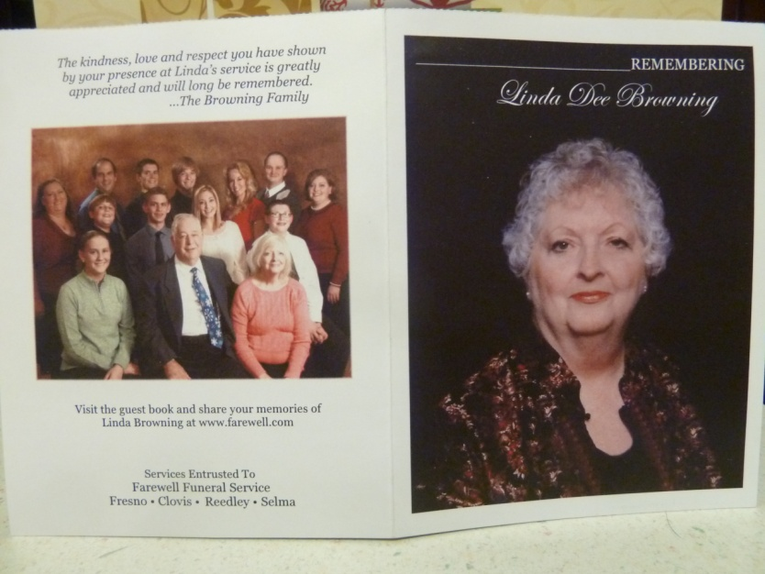 Linda was diagnosed with a liver disease and eventually passed away in 2013? (I think that’s the year). Roy is lonesome and has dementia. Barbara & Russell live in Sacramental California and Roy lives in Fresno, about 3 hours away, but they come down about every week to check on him and help him. Julianna & Phil live in the state of Washington. She wasn’t able to have children, so they do foster care and they adopted a little boy.

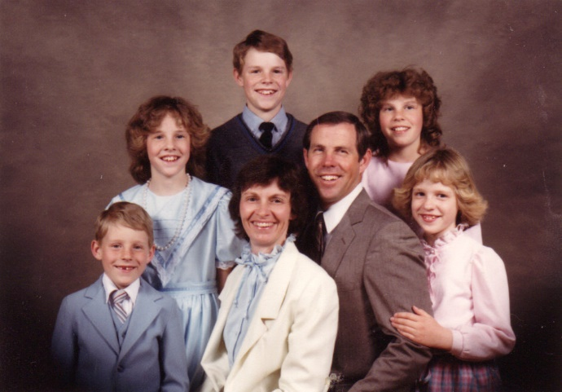**Irven** is dating a real nice girl in Salt Lake, and is working as a milk man. Irven married that wonderful girl, Sandy, in the Salt Lake Temple. They were both 28 when they married. They wanted to have a large family, so their children are close together – Andrea, Doug, Jennifer, Christine and Mark. They all married in the temple, except Andrea, who is a beautiful, sweet and talented young woman, but she didn’t find the right guy – at least not yet and she is 44 now (2018). I wrote in another chapter, move to Taylorsville, how they liked our home and area, so they bought a home about a block away from us. However, we were both only there for about 9 months. We moved to Erda, where Ken ran the three stake farm, and Irven, Sandy and family moved to Pocatello, Idaho and then to a town (Can’t remember the name) by Firth, Idaho where we came and lived for two years. I’m sure I have also wrote about when they came to live with us for nine months after they had moved to Mesa Arizona, but financially it was a bad move and they needed to move back and get back on their feet. We had lived with Ken’s mom, when we moved back from Arizona the 3rd time and were having a tough time financially, so we agreed to let them live with us for awhile. It worked out great for Sandy and I. We took turns cooking and we cleaned house together. We had fun visiting and laughing and enjoyed each other. Ken finally didn’t like the arrangement and wanted them to move. They did and I don’t think they had hard feelings. They found a home in Clearfield where they lived for several years.

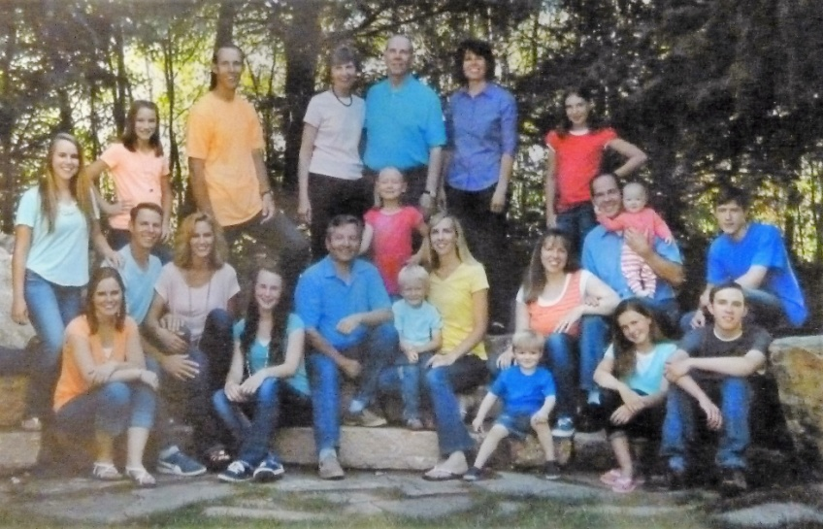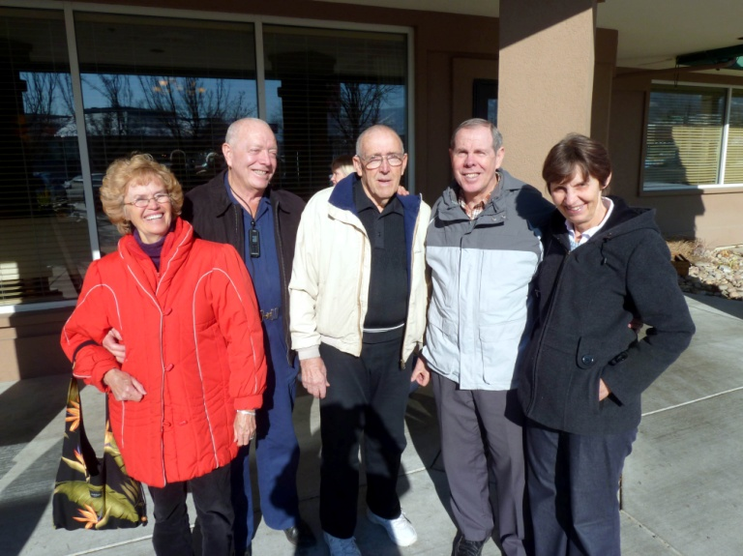Irven had a terrible accident when he was working for NFIB. He was driving and a storm came up, he was hit by a semi and it should have killed him, but he survived. He has had some operations and has a limp, can’t drive, so had to retire early. When they lived in Clearfield, we got together to play games and visit quite often.. They usually invited Bryce & Deanna (who were their good friends as Irven and Bryce became good friends in high school) and Ken and I for New Year’s Eve and we would eat and play games. They have now moved to Smithfield, by Logan and have a nice home. Their children – Jennifer, Christine and Mark all live in the Logan area and talked them into moving up closer to them. We visit them occasionally, stay overnight and mainly play games.

This is a picture of their family of their family in 2017.